- Project title and problem statement
Our project addresses the challenge of grouping unlabelled e-commerce customers into behavioral segments, and it is ideal for data mining because unsupervised algorithms can automatically discover hidden patterns in massive transactional data without human bias.
- Data and preprocessing completed
a. Show the dataset
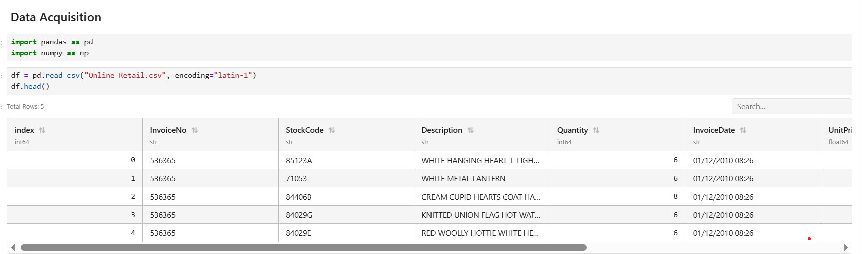
b. number of records
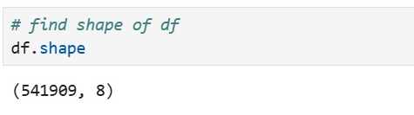
c. important variables
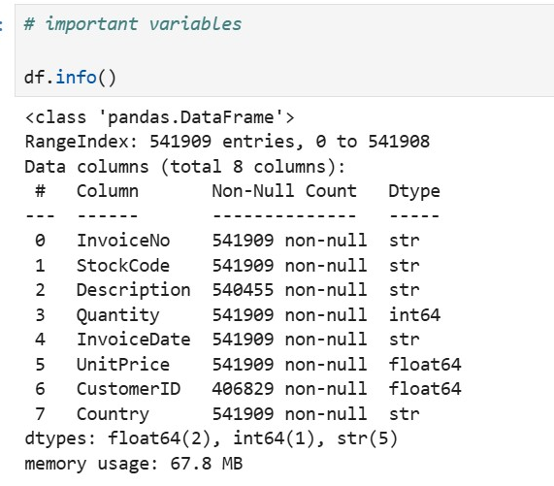
InvoiceNo records the visit of the customer at the store
StockCode uniquely identifies items
CustomerID uniquely identifies customers
Country tells where the customers are coming from

d. data-quality issues identified
- Missing data in some columns
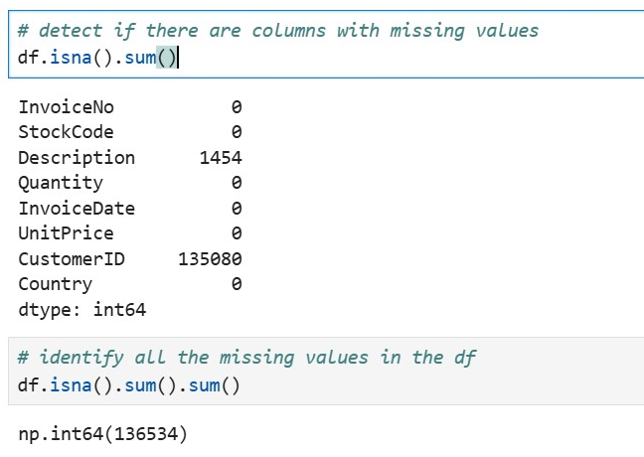
Figure 1: Found a total of 136,534 missing values
- Outliers
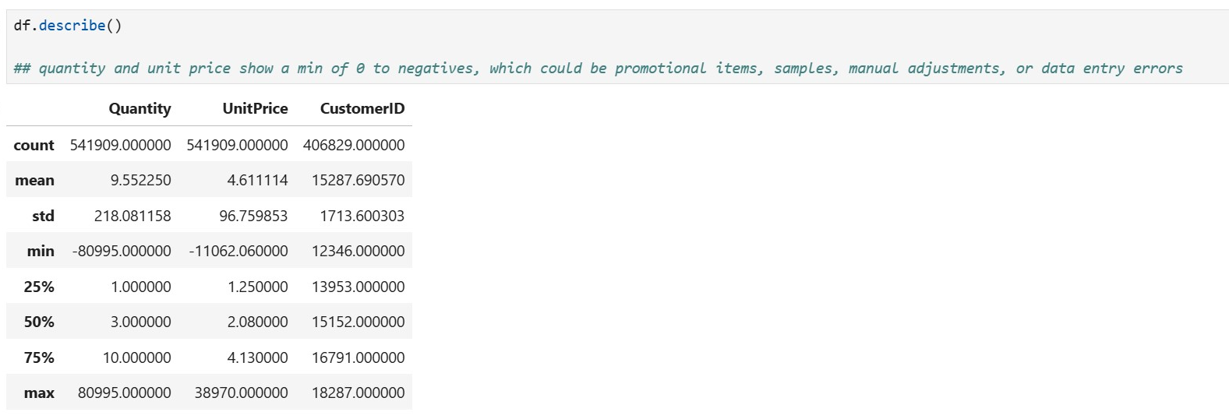
Figure 2: 0 to negative quantity and unit prices
- Duplicates
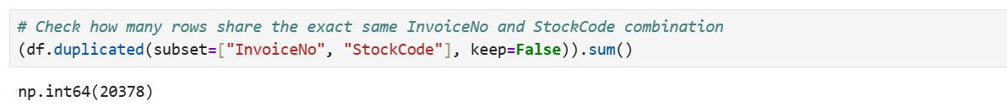
Figure 3: There were about 20k duplicates
e. preprocessing activities actually completed
i. Removal of missing values
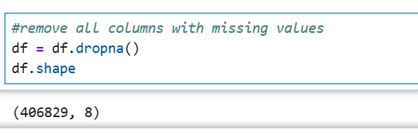
ii. Removed outliers
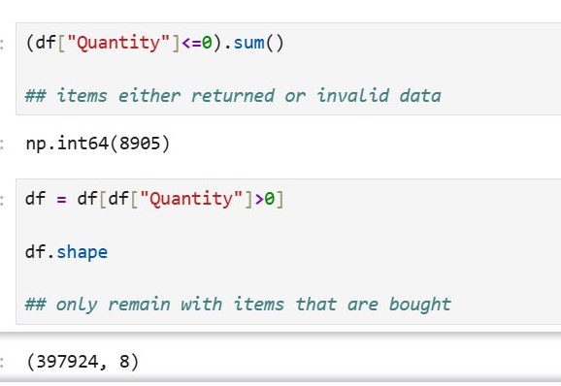 | 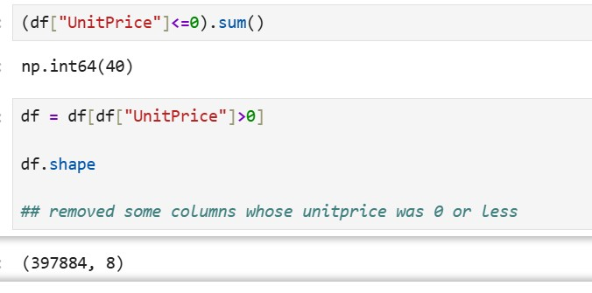
iii. Removed duplicates
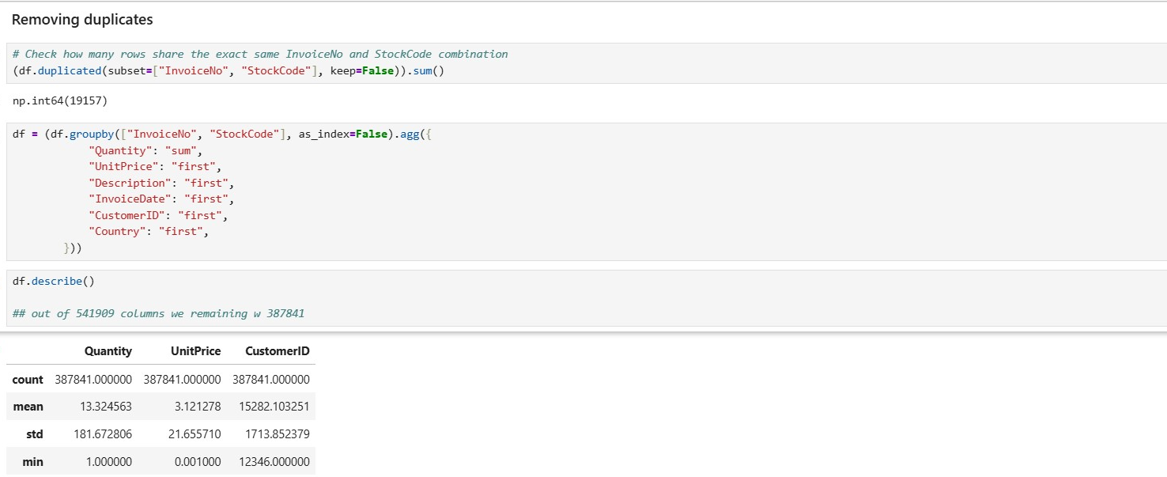

- Exploratory Data Analysis (EDA)
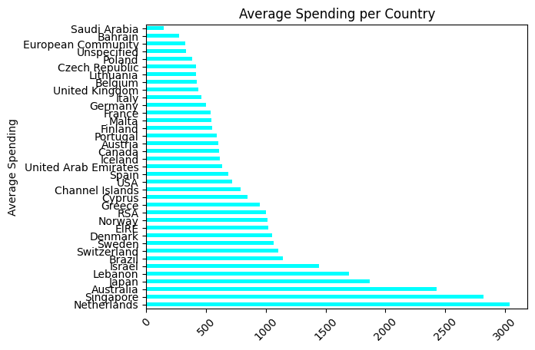
Figure 4: Netherlands has the highest spending per invoice while Saudi has the least
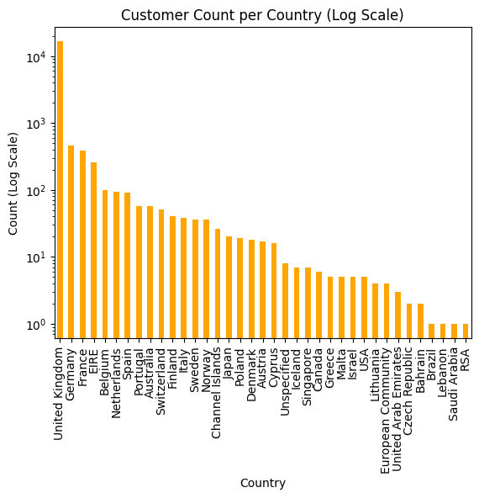
Figure 5: The UK leads with 10k+ customers while RSA, Brazil, Lebanon and Saudi tails with just 1 customer over the 1yr period
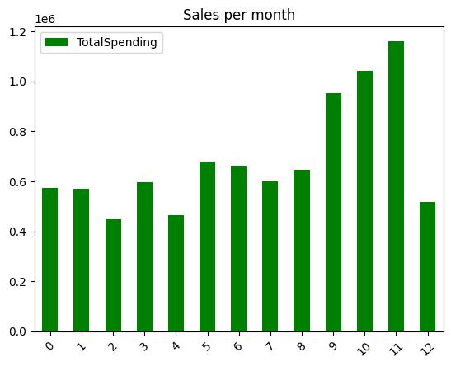
Figure 6: September, October and November have the highest number of sales, while feb, mar and apr have the lowest
- Selected data-mining technique
Technique: Unsupervised Machine Learning - K-Means Clustering combined with RFM (Recency, Frequency, Monetary) feature engineering.
Justification: Because transactional e-commerce logs lack pre-existing customer category labels, supervised classification is impossible. Unsupervised clustering is ideal because it automatically discovers hidden, organic behavioral groupings from unlabelled data without human bias. RFM transforms raw invoice lines into distinct numerical behavioral indicators per customer, making them mathematically quantifiable for clustering algorithms.
- Demonstration of the data-mining process
The data-mining pipeline implemented in Python follows these sequential steps:
- Data Cleaning & Preprocessing: Filtered out rows with zero or negative unit prices (UnitPrice > 0) and handled missing values to prevent distortion.
- Feature Engineering (RFM): Aggregated 400k+ transaction rows down to unique customer profiles, calculating:
- Recency: Days since the customer's last purchase relative to a snapshot date.
- Frequency: Total number of unique invoices/visits.
- Monetary: Total spending (Quantity * UnitPrice).

- Feature Scaling: Applied StandardScaler to normalize the RFM features so that large monetary values do not disproportionately dominate distance-based clustering metrics.
- Model Execution: Iterated through cluster sizes (e.g., k=2 to 10) using K-Means to evaluate inertia (within-cluster sum of squares) and pinpoint the optimal number of clusters.

- Initial data-mining results
Show the results obtained so far. Depending on your technique, this may include a confusion matrix and classification metrics, regression metrics, clusters, association rules with support/confidence/lift, or identified anomalies.
Cluster Inertia & Elbow Curve: Running K-Means across multiple values of k generated a decreasing inertia curve, allowing us to identify the optimal elbow point for segmenting customers.
Customer Behavioral Groupings: The model successfully segmented the customer base into distinct cohorts—such as a high-value loyalist group (high frequency, high monetary, low recency) versus at-risk or one-time retail buyers.
Geographic Distribution: Initial data exploration revealed a heavy domestic concentration led by the United Kingdom (16,673 customers), supported by a robust international tier across Europe (e.g., Germany with 457 and France with 390 customers).

- Interpretation of results
EDA from above.
- Connection to the original problem
Explain how the findings obtained so far contribute to solving the problem you identified at the beginning of the project.
- Evidence of actual work completed
shown in code.

2. Demonstration of the Data-Mining Process
3. Initial Data-Mining Results
4. Interpretation of Results
- Insight 1: The Pareto Spending Skew: Customer spending follows a heavy right-skewed distribution, proving that a small percentage of wholesale or high-frequency buyers drive a disproportionate share of total revenue.
- Insight 2: Behavioral Segmentation: K-Means successfully separated casual gift buyers (low frequency, low spend) from core active shoppers, giving the business clear boundaries for customer tiering.
- Insight 3: Geographic Concentration: While international markets span over 30 countries, the UK market dominates volume, meaning marketing strategies must balance localized UK retention with targeted European cross-border campaigns.
5. Connection to the Original Problem
- Solving the Core Problem: The business previously lacked any structure to categorize buyers, making personalized marketing impossible.
- Business Value: By mapping customers into distinct data-driven clusters, the company can now automatically identify churn risks (dormant high-value customers), optimize Customer Lifetime Value (LTV) through tailored loyalty perks, and design targeted promotional campaigns instead of relying on generic mass marketing.
6. Evidence of Actual Work Completed
- Working Files & Scripts: Python scripts and Jupyter notebooks (segmentation.py, customer segmentation ml.ipynb) containing pandas data pipelines, data cleaning scripts, and Scikit-Learn model training loops.
- Visualizations & Outputs: Logarithmic scale bar charts visualizing global distribution, RFM summary tables, and cluster inertia evaluation plots.

